A Sample Paper Prepared for CEUR-WS using Microsoft Word
First Author¹,*, Second Author² and Third Author¹
¹ Department of Example Studies, Example University, 1-2-3 Example, Tokyo 100-0000, Japan
² Example Research Laboratory, 4-5-6 Sample, Osaka 530-0000, Japan
Abstract
This Word template is designed for authors who prefer to draft a paper while seeing an appearance close to the CEUR-WS single-column output. The final manuscript should still be converted to the official CEURART LaTeX format. To make that conversion reliable, the template uses ordinary Word paragraphs, heading styles, inline figures, simple tables, and a small number of semantic styles for the front matter.
Keywords
CEUR-WS, Word template, paper preparation, LaTeX conversion

Introduction
This is a sample paragraph showing the intended appearance of the manuscript in Word. Authors may replace the sample text directly. The paragraph width, font size, and spacing are chosen to resemble the CEURART single-column layout without attempting to reproduce it exactly.
Use Word styles rather than manual formatting wherever possible. In particular, use Heading 1, Heading 2, and Heading 3 for section levels. Do not type section numbers manually; the numbering shown in this template is generated by Word and can be regenerated by LaTeX after conversion.
A typical paper may cite previous work using bracketed references such as [1] and [2, 3]. The final BibTeX entries can be prepared during the LaTeX conversion.

Preparing the manuscript

Text, lists, and emphasis
Keep one logical paragraph as one Word paragraph. Bold and italic emphasis may be used normally. Avoid tabs, repeated spaces, floating text boxes, and multi-column sections, because they are difficult to translate consistently into LaTeX.
- Use native Word bullet lists for itemized lists.
- Keep each item in a separate paragraph.
- Use simple, inline objects whenever possible.

Figures
Figures should be inserted as inline pictures. A figure caption should be a separate paragraph immediately below the figure. If third-party material is used, include the source and license information in the caption.
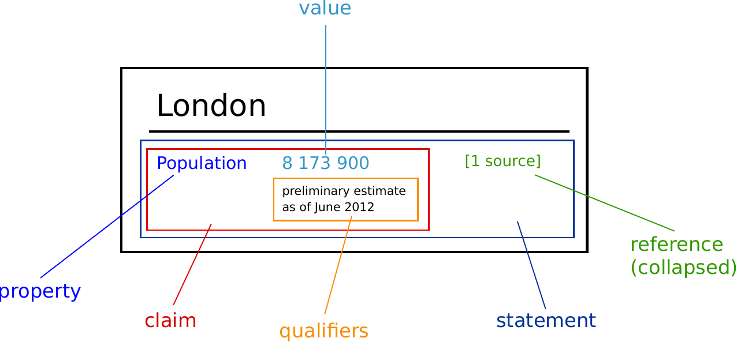
Figure 1: Example figure. Chart about Wikidata (source: freesvg.org/1438642735, public domain).

Equations
Simple equations can be entered with Word Equation or, for the easiest conversion, as linear LaTeX notation. The following line illustrates the expected visual placement.
Q = H × S

Tables
Use ordinary Word tables. Avoid merged cells unless they are essential. The final LaTeX conversion can translate these tables into tabular or tabularx environments.
Table 1: Example of a simple conversion-friendly table
Item | Description | Result
A | A normal text cell that converts easily. | OK
B | Use short headings and avoid nested tables. | OK
C | Keep the caption outside the table. | OK

Discussion
This Word file gives authors a reasonable impression of the CEUR-WS appearance while retaining a simple structure that can be mapped to CEURART during conversion. The final PDF should be generated from the official LaTeX source.

Acknowledgments
The authors thank the workshop organizers and reviewers for their comments.

Declaration on Generative AI
The author(s) have not employed any Generative AI tools. Replace as required by the current CEUR-WS policy.

References
[1] L. Lamport, LaTeX: A Document Preparation System, Addison-Wesley, Reading, MA, 1986.
[2] A. Author, B. Author, A sample article title, Journal of Examples 10 (2026) 1–10. doi:10.0000/example.
[3] C. Author, A sample proceedings paper, in: Proceedings of the Example Workshop, 2026, pp. 20–28.
Template notes — delete this page before submission
This page is intentionally practical. The visual template above is meant for drafting; the official publication file remains the CEURART LaTeX/PDF. Keeping the Word structure simple makes conversion much more reliable.
Title: Replace the sample title. Do not insert manual line breaks unless unavoidable.
Authors: Use full names. Keep affiliations, email addresses, ORCID, and corresponding-author status explicit.
Sections: Use Heading 1 / Heading 2 / Heading 3. Do not type section numbers manually.
Body text: Use Normal style. One logical paragraph should be one Word paragraph.
Figures: Insert pictures inline with text. Put the caption immediately below the figure.
Tables: Use simple Word tables. Put the caption above the table. Avoid nested or heavily merged tables.
Lists: Use Word List Bullet / List Number rather than typing bullet characters or numbers yourself.
Equations: Word Equation is acceptable for drafting, but complex equations may need manual checking after LaTeX conversion.
References: Numbered references may be drafted in Word; final references can be converted to BibTeX.
Page layout: Do not add columns, text boxes, floating shapes, manual page numbers, or custom headers/footers.
Suggested Word → CEURART mapping
Word element | CEURART element
CEUR Title | \title{...}
CEUR Author | \author[...] {...}
CEUR Affiliation | \address[...] {...}
CEUR Abstract | abstract environment
CEUR Keywords | keywords environment
Heading 1 | \section{...}
Heading 2 | \subsection{...}
Heading 3 | \subsubsection{...}
Inline picture + caption | figure + \includegraphics + \caption
Simple Word table | table + tabular/tabularx
CEUR Reference | BibTeX / thebibliography

